Determination of the antioxidant properties of flavanones and flavanone metabolites

Kathryn A. Costello
Department of Chemistry and Biochemistry
Southwestern University

Introduction

Flavonoids, a classification of polyphenolic compounds, are plant metabolites with a wide variety of functions. In the human diet, they are most commonly found in fruits, vegetables, wines, and teas (Crozier et al. 2006). Flavonoids are also known antioxidants that help reduce oxidative damage to biological macromolecules by donating an electron to a free radical species or by preventing a free radical chain reaction from being generated (Lobo et al. 2010). In addition, some flavonoids have displayed a potential to stop cancer cell growth (So et al. 1996). For example, So and co-workers (1996) demonstrated that the development of mammary tumors was postponed in rats that were given orange juice, which is known to contain flavonoids. They attributed the delay in tumor growth to the presence of the flavonoid naringenin in the juice that the rats ingested (So et al. 1996).
Before metabolism, humans cannot easily excrete flavonoids because the presence of two aromatic rings in the flavonoid structure limits the aqueous solubility. When flavonoids are metabolized, they acquire hydroxyl, sulfonyl, methyl, or carboxyl groups, all of which increase flavonoid solubility (Chen et al. 2014). Although there are multiple pathways for this process to occur, metabolism by UDP-glucuronosyltransferase (UGT) enzymes is one of the most common and important in vertebrates. UGT enzymes catalyze the addition of a glucuronide group at nucleophilic sites on the flavonoid to form flavonoid-O-glucuronides (King et al. 2000). The expression of these enzymes varies with the type of tissue. For example, UGT 1A1 is primarily expressed in the liver, stomach, small intestine, and colon, while 1A4 is only expressed in the liver (Ohno and Nakajin 2009). Mata-Bilbao and co-workers (2007) demonstrated that the naringenin aglycon, a flavanone, had a lower extended exposure and mean residence time in plasma than the naringenin glucuronide. Their results demonstrate that parent flavonoid aglycones are not present in plasma for an extended period of time (Mata-Bilbao et al. 2007).
Flavanones, a subclass of flavonoids, are commonly found in both the juices and peels of citrus fruits and are readily metabolized through hydroxylation, glycosylation, and O-methylation processes (Crozier et al. 2006). Flavanones have a variety of structures, and differences may lead to variations in their biological activities (Chen et al. 2014). There have been many studies conducted on the chemical and biological properties of flavanones, but less research exists on flavanone metabolites. Although the properties of flavanones themselves are important, metabolites are more biologically relevant and may be found in blood, plasma, and bile (Manach and Donovan 2004). Yoshimura, Sano, Kamei, and Obata (2009) investigated the metabolites of naringenin chalcone in rats. They identified three major chalcone metabolites as naringenin chalcone-2’-O-β-D-glucuronide, naringenin-7-O- β-D-glucuronide, and naringenin-4’-O- β-D-glucuronide in the urine. However, they only found naringenin chalcone-2’-O-β-D-glucuronide in the plasma (Yoshimura et al. 2009).
The antioxidant properties of flavonoids have been extensively studied. However, less research has been conducted on flavonoid metabolites, even though flavonoids primarily exist in the body in their metabolized forms. Therefore, the current study investigates how flavanone structure affects the antioxidant properties of the resulting metabolite. Since a structure-activity relationship exists between enzyme and substrate, we also examined how flavanone structure affects the rate of metabolite product formation. In particular, we studied the glucuronidation of six mono-hydroxyflavanones (HF) (2’-HF, 3’-HF, 4’-HF, 5,7-dimethoxy-4’-HF, 6-HF, and 7-HF, see Figure 1) by UGT enzymes and compared the antioxidant properties of the flavanone aglycon and glucuronide metabolite. Glucuronidation occurs at hydroxyl groups, and because the flavanones in this study were mono-hydroxyflavanones, there was only one possible site for glucuronidation, resulting in mono-glucuronide metabolites.

Methods
Reagents:
The six hydroxyflavanones (2’-hydroxyflavanone, 3’-hydroxyflavanone, 4’-hydroxyflavanone, 5,7-dimethoxy-4’-hydroxyflavanone, 6-hydroxyflavanone, and 7-hydroxyflavanone) were of the highest available purity and were purchased from Indofine Chemical Company, Inc. (Hillsborough, TN). Uridine 5’-diphosphoglucuronic acid (UDPGA), 2,2’-diphenyl-1-picrylhydrazyl (DPPH), and formic acid were obtained from Sigma Aldrich (St Louis, MO). HPLC-grade acetonitrile was acquired from Pharmco-Aaper (Farmers Branch, TX), and reagent-grade potassium phosphate was procured from Mallinckrodt Chemical (St. Louis, MO). UGT enzymes (1A3 and 1A9) were purchased from Corning Life Sciences (Corning, NY).

Flavanone Glucuronide Preparation:
Flavanone glucuronides were prepared using the method developed by Robotham and Brodbelt (Robotham and Broadbelt 2011). Sixty-five microliters of 2 mM aqueous UDPGA, 378.75 µL of 20 mM pH 7.0 potassium phosphate buffer, and 7.50 µL of 10 mM flavanone solution in methanol were added to a 30 µL aliquot of a UGT enzyme in a 2 mL tube. The mixture was blended and then placed in a heating block at 37 °C for 24 hr. The reaction was stopped by adding 1.5 mL of acetone then centrifuged for 10 min at 16,000 x g. The supernatant liquid was removed, placed in a new 2 mL tube, and concentrated by vacuum centrifugation for 80 min on low heat. The remaining liquid was stored at 4 °C until it was analyzed.

Mass Spectral Analysis of Enzyme Mixtures:
Enzyme mixtures for 2’-, 5,7-dimethoxy-4’-, 6-, and 7-HF were selected for mass spectral analysis because they embody a representative sample of the flavanones in this study. The 2’-HF contains a B-ring hydroxyl group, while the 6-HF and 7-HF each have an A-ring hydroxyl group. The 5,7-dimethoxy-4’-HF has a hydroxyl group on the B-ring as well as two methoxy groups on the A-ring. Analysis of the above enzyme mixtures was performed with an Agilent 1260 Infinity high-performance liquid chromatograph (HPLC) linked to an Agilent 6530 Accurate-Mass QTOF mass spectrometer equipped with electrospray ionization (ESI). Detection was determined in positive mode from 100–3200 m/z with a scan rate of 1.00 spectra/sec. The column was a Gemini C18 (3.5 micron, 2.1 × 50 mm), and the mobile phase flow rate was 0.45 mL/min. Mobile phase A was 10% aqueous formic acid, mobile phase B was 10% formic acid in acetonitrile, and the injection volume was 5.0 µL. The following gradient elution was used: 0–2 min, 95% A; 2–12 min, 95% A to 10% A. Parameters such as gas temperature (350 °C), gas flow rate (12 L/min), nebulizer pressure (50 psig), and fragmentator (180 units) were applied to optimize the analysis.

Chromatographic Analysis of Enzyme Mixtures:
A Waters 2487 dual (λ) HPLC (Milton, MA) equipped with a dual absorbance detector and a Waters Symmetry C18 column (2.1mm × 50 mm, 3.5 µm particle size) was used to separate the flavanone glucuronide from the parent flavanone. Mobile phase A was 0.33% aqueous formic acid and mobile phase B was 0.33% formic acid in acetonitrile. The flow rate was 0.45 mL/min. For the DPPH antioxidant assay (described below), the following gradient elution was used: 0–2 min, 5%–90% B; 2–12 min, hold at 90%; 12–17 min, 90%–5% B; 17–27 min, equilibration at initial conditions, with an injection volume of 10 µL. For reaction rate determination (see below), the following gradient elution was used: 0–2 min, 5%–90% B; 2–4 min, hold at 90% B, 4–5 min 90%–5% B; 5–7 min, hold at 5% B with an injection volume of 20 µL.
All chromatograms were collected at wavelengths of 320 and 355 nm, and integrated peak areas were determined for flavanones and flavanone glucuronides. Calibration curves of chromatographic peak area as a function of concentration were prepared for flavanones using analytical standards over a concentration range of 10–500 µM.

Determination of Flavanone and Metabolite Antioxidant Properties:
The antioxidant properties of the flavanones and flavanone glucuronides were determined using a DPPH chromatographic assay modified from the method of Cheng, Moore, and Yu (Cheng et al. 2006). A 1:1 mixture of 6 mM DPPH in 50% acetone and flavanone glucuronide sample was allowed to incubate for 30 min at room temperature. The mixture was directly injected into the HPLC using the analytical method described above. Integrated peak areas were determined for the flavanone and flavanone glucuronide before and after the addition of DPPH then compared to determine the relative antioxidant activity of each compound. Antioxidant activity was expressed as the percent of the respective flavanone or flavanone glucuronide metabolite chromatographic peak area that remained after the addition of DPPH. The relative antioxidant capacity was therefore calculated for both the aglycon and flavanone glucuronide as follows: percent remaining = (peak area after the addition of DPPH)×100/(initial peak area).

Analysis of Glucuronidation Reaction Rates:
Rates of glucuronidation of all six flavanones were determined using a method modified from the procedure used by Chen, Xie, Chen, and Zeng (2008) (Chen et al. 2008). Enzyme reaction mixtures were prepared as described above with an initial flavanone concentration ranging from 10–200 µM to determine the optimum aglycon concentration for further analysis, and the samples were directly injected into the HPLC using the analytical method described above. An optimum initial flavanone concentration of 30 µM was selected and used for all subsequent enzyme reactions. Enzyme reactions were initiated then analyzed using HPLC by removing mixture aliquots at the following approximate time points: 0.33, 0.67, 1, 6, 7, 21, and 24 h. Plots of flavanone concentration as a function of time were created and used to calculate the following information for each flavanone: reaction rates (initial and intermediate) and the percent flavanone remaining at 21 hours. Rate data were modeled using power (7-HF) and exponential (2’-, 3’-, 4’-, 5,7-dimethoxy-4’-, and 6-HF) fits to interpolate flavanone concentrations at specific reaction times.
Statistical Analysis:
All statistical analyses including calculations of mean values and standard errors were performed using the Statistical Package for the Social Sciences (SPSS), version 21 or StatPlus-statistical analysis program for Microsoft Excel, version 5. Homogeneity of variance was determined using Levene’s test, and data were tested for normality using the Shapiro–Wilk test prior to completing any statistical analyses. The difference in antioxidant properties between flavanones and flavanone glucuronides was evaluated using an independent samples t-test with homogeneity of variance determined using an F-test prior to analysis. One-way analysis of variance (ANOVA) was used to determine whether statistical differences in antioxidant properties existed based on molecular structure. For all analyses, statistical significance was determined at the p = 0.05 level.

Results and Discussion
Rates of Flavanone Glucuronidation:
The rate indicates the speed at which a substrate is converted to product by a particular enzyme, and rates of glucuronidation by UGT1A3 were studied for the six flavanones. How quickly an enzyme reaction occurs is affected by enzyme and substrate concentrations as well as the presence of inhibitors or activators. In addition, there is usually an optimum substrate concentration for a given enzyme concentration (Nelson and Cox 2013). Below, we compare the rates of glucuronidation of six flavanones (2’-, 3’-, 4’-, 5,7-dimethoxy-4’-, 6-, and 7-HF) by UGT1A3, as summarized in Table 1.
Glucuronidation of 7-HF displayed the fastest initial rate (1.103 µM/min) and intermediate rate (0.102 µM/min), while the glucuronidation of 3’-HF was the slowest for both initial and intermediate rates (0.243 µM/min and 0.031 µM/min, respectively). In addition to displaying the fastest reaction rate, the largest percent conversion of flavanone to flavanone-O-glucuronide occurred for the glucuronidation of 7-HF (96%), while glucuronidation of 3’-HF yielded the lowest percent conversion (30%).
Lewinsky et al. (2005) studied the structure-activity relationship between flavonoids and another UGT enzyme, UGT1A10. The enzyme activity was calculated based on the formation of glucuronidated product and expressed as nmol (of product formed) min⁻¹mg⁻¹ UGT protein. They demonstrated that activity of mono-hydroxylated flavonoids with B-ring hydroxyl groups is dependent upon hydroxyl group location with C4’ > C3’ > C2’. However, in our study of flavanones with UGT1A3, 2’-HF displayed faster initial and intermediate rates of reaction as well as a higher percent flavanone conversion (64%) than 3’-HF (30%). It was also found that 2’-HF had faster initial and intermediate rates than 4’-HF. However, the percent flavanone conversion for 4’-HF was greater (66%) than for 2’-HF. These discrepancies are most likely due to the fact that UGT1A3 and UGT1A10 have slightly different active sites and therefore different affinities for hydroxyl groups at certain positions (Wong et al. 2009). Flavonoids with an A-ring hydroxyl group at the C6 position also displayed high rates of glucuronidation by UGT1A10 (Lewinsky et al. 2005). The results of Lewinsky and coworkers were consistent with our study where 6-HF displayed the second highest percent conversion (72%).
Flavonoids with a hydroxyl group at the A-ring C7 position have been found to be UGT1A3 substrates (Xie et al. 2011). Steric hindrance, nucleophilicity, and the locations of hydroxyl groups have been shown to affect the rate of flavonoid glucuronidation. Glucuronidation at the C7 hydroxyl group may be favorable, in part, because there is minimal steric hindrance. In contrast, Wong and collaborators found that the C5 hydroxyl group displayed no or very low rates of glucuronidation, which may be attributed to several factors. The C5 hydroxyl group is located near the carbonyl group on the picryl ring, which could sterically hinder glucuronidation at the C5 position. Intramolecular hydrogen bonding with the same carbonyl as well as decreased nucleophilicity due to resonance may also reduce glucuronidation at the C5 position (Wong et al. 2009). In addition, Yin et al. (1994) found that the rate of metabolism of phenolic compounds increases with greater nucleophilic character of the phenolate anion (Yin et al. 1994). Although none of the flavanones in this study had a hydroxyl group at the C5 position, steric hindrance, intramolecular hydrogen bonding, and nucleophilicity are important factors to consider when providing possible explanations for flavanone rates of glucuronidation.
Unlike a hydroxyl group at the C5 position, hydroxyl groups at the C6 or C7 positions are not sterically hindered by the picryl ring C4 carbonyl, nor do they engage in intramolecular hydrogen bonding with the C4 carbonyl group, which leaves their hydroxyl groups readily accessible for metabolism with UGT enzymes. In our study, flavanones with a hydroxyl group at the C6 or C7 positions displayed the fastest initial and intermediate rates of glucuronidation. Therefore, in general, flavanones with the hydroxyl substituent on the A ring displayed greater rates of glucuronidation than flavanones with the hydroxyl group on the B ring.
The 5,7-dimethoxy-4’-HF displayed the lowest percent conversion to the corresponding glucuronide (48%), which is much less than the percent of 4’-HF converted (66%). Enzyme substrates interact with specific amino acids in the enzyme active site through hydrogen bonding, hydrophobic, or hydrophilic contacts. These specific interactions contribute to an enzyme’s substrate specificity. Because 5,7-dimethoxy-4’-HF has two methoxy groups on the opposite side of the molecule from the hydroxyl group, both sides of the molecule are somewhat polar, which may affect the interactions this flavanone has with the UGT enzyme active site. The 5,7-dimethoxy-4’-HF did not have distinctly polar and nonpolar sides and most likely displayed a lower percent conversion than 4’-HF because the two methoxy groups on 5,7-dimethoxy-4’-HF may have inhibited its ability to fit into the active site of UGT1A3. In contrast all other flavanones in this study displayed distinct polar and nonpolar regions (see Figure 1).

Chromatographic Analysis of Enzyme Mixture:
Due to the complexity of our enzyme mixtures, chromatographic analysis was required to quantify flavanones and flavanone metabolites. We first analyzed the six mono-hydroxyflavanones in this study by HPLC and observed a chromatographic peak eluting around 2.2 min (Figure 2A). After glucuronidation, a second chromatographic peak was observed at approximately 2 min, indicating the presence of the flavanone-O-glucuronide (Figure 2B). When flavonoids are glucuronidated by UGT enzymes, the glucuronide group primarily adds at hydroxyl substituents (Chen et al. 2014). Because all of the compounds in this study are mono-hydroxyflavanones, all metabolites formed only have one glucuronide group.
Because flavanone-O-glucuronides are not available commercially, mass spectral analysis was used to confirm the presence of these glycons (see Table 2). We observed that the flavanone glucuronide always eluted first because the glucuronide group increases the polarity of the metabolite relative to the parent aglycon. For example, 7-O-glucuronide had a retention time of 2.37 min and a base peak of 417 m/z, and 7-HF had a retention time of 2.83 min and a base peak of 241 m/z. The 176 m/z difference between the mass of the flavanone glucuronide (417 m/z) and the parent flavanone (244 m/z for all flavanones except 5,7-dimethoxy-4’-HF) confirms the addition of the glucuronide group to form the flavanone metabolite.

Antioxidant Properties of Flavanones and Glucuronide Metabolites:
After confirming the presence of the flavanone glucuronide with mass spectral analysis, the antioxidant capacities of flavanones and their metabolites could be measured. Although there are multiple assays to quantify antioxidant activity, the DPPH assay is one of the most commonly used methods to determine the antioxidant properties of phenolic compounds. Most radical scavenging assays occur through either a hydrogen atom transfer (HAT) or an electron transfer (ET). However, several studies suggest that the DPPH reaction occurs through both HAT and ET mechanisms (Xie and Schaich 2014; Huang et al. 2005). We used HPLC analysis in combination with DPPH to assay the relative radical scavenging abilities of six different flavanones and their respective flavanone-O-glucuronides. DPPH is a meta-stable radical in which the radical resides on a central nitrogen atom (Figure 3). Antioxidant access to the radical may be limited due to the orientation of two benzylic nitro substituents as well as two orthogonal phenyl groups. Upon the addition of DPPH to the purified enzyme reaction mixture (containing both flavanone and flavanone-O-glucuronide), a decrease in peak area for the flavanone and flavanone-O-glucuronide was observed (Figure 2C). Integrated peak areas for the flavanone and flavanone-O-glucuronide before and after the addition of DPPH were used to determine each compound’s relative antioxidant activity, expressed as the percent flavanone or flavanone-O-glucuronide remaining after reaction with DPPH. Therefore, there is an inverse relationship between the percent remaining of a particular compound and its antioxidant activity, with lower percent remaining values corresponding to larger antioxidant activities, while greater percent remaining values correspond to lower antioxidant activities.
Relative to the other flavanones in this study, 7-HF displayed the highest antioxidant capacity (55% flavanone remaining after reaction with DPPH), while 5,7-dimethoxy-4’-HF had the lowest (78% flavanone remaining after reaction with DPPH) (Figure 4). The ability of a compound to be an antioxidant depends on how well it can delocalize the resulting radical that forms by either donating a hydrogen atom or an electron. Radical delocalization often occurs through resonance, and, the greater number of stable resonance structures a compound can form, the higher its antioxidant capacity (Klein 2012). The 7-HF is able to form five resonance structures, while the other flavanones in this study can only form four resonance structures, which may relate to 7-HF having a higher antioxidant capacity relative to the other flavanones (Scheme 1).
Xie and Schaich (2014) studied the antioxidant properties of a variety of phenolic compounds using the DPPH assay. They suggested that steric hindrance plays a role in an antioxidant’s interaction with DPPH and proposed that certain phenolic compounds have less accessibility to the radical site because DPPH has two orthogonal phenyl groups as well as two nitro groups positioned above and below the radical. Therefore, in our study, the location of the hydroxyl group on each of the flavanones is likely a factor that ultimately affects flavanone antioxidant capacities. In particular, steric hindrance may play a role in the relative antioxidant properties of 2’-, 3’-, and 4’-HF. In 2’-HF, the hydroxyl group is located close to the picryl ring, which may impede the flavanone’s ability to interact with the DPPH radical. As the hydroxyl group moves away from the picryl ring (from the 2’ to the 4’ position), the antioxidant capacity of the flavanone subsequently increases. This reasoning may also hold true for 6-HF, which has a hydroxyl group that is closer to the picryl ring than 7-HF does. The 5,7-dimethoxy-4’-HF has lower observed antioxidant capacity than other flavanones which may be attributed to the two A-ring methoxy groups at C5 and C7 in addition to the B-ring 4’-hydroxyl group (Figure 1). Although trends were evident in our data, further analysis revealed that the percent flavanone remaining was statistically the same for all flavanones, which is likely due to the larger standard error from analyzing replicate samples.
In addition, we also compared the relative antioxidant capacities of the flavanone-O-glucuronides. Relative to the other flavanone metabolites that were analyzed, 6-O-glucuronide exhibited the lowest antioxidant capacity (83% flavanone glucuronide remaining), closely followed by 4’-O-glucuronide (76% flavanone glucuronide remaining). Antioxidant capacities among the flavanone glucuronides were 3’-O-glucuronide > 5,7-dimethoxy-4’-O-glucuronide ≈ 7-O-glucuronide > 2’-O-glucuronide > 4’-O-glucuronide > 6-O-glucuronide. It is notable that 5,7-dimethoxy-4’-O-glucuronide, unlike its parent compound, had similar a antioxidant capacity to the other flavanone glucuronides. However, further analysis showed the antioxidant activities of the flavanone glucuronides were not statistically different.
Finally, the relative antioxidant properties of the flavanones and their respective glucuronides were also analyzed using the DPPH assay. The 5,7-dimethoxy-4’-O-glucuronide had a greater antioxidant capacity than its parent compound. 2’-HF and 3’-HF displayed lower antioxidant capacities than their respective metabolites, and 4’-O-glucuronide, 6-O-glucuronide, and 7-O-glucuronide all displayed lower antioxidant activities than their parent compounds. However, no statistical differences were noted.
In a study similar to ours, Villaño et al. (2005) studied the antioxidant properties of wine phenolic compounds, as well as their metabolites using the 2,2’-azino-bis(3-ethylbenzothiazoline-6-sulphonic acid) (ABTS), DPPH, and oxygen radical absorbance capacity (ORAC) assays. In particular, the authors analyzed flavan-3-ols, which are structurally similar to flavanones but contain a hydroxyl group at the C3 position and a double bond between C2 and C3 of the picryl ring. Villaño et al. found that the antioxidant capacities of flavan-3-ols correlated well between the DPPH and ABTS assays but not with the ORAC assay. In addition, they observed that, in general, the antioxidant properties of the phenolic metabolites are comparable to those of the parent phenolic compounds. Because all phenolic metabolites were commercially available and not generated in the laboratory, the authors reported that it was difficult to discern the parent compounds of these metabolites in order to directly compare the antioxidant activities of a parent compound to its respective metabolite. In our study, the antioxidant capacities of all flavanones and flavanone glucuronides were statistically the same according to the DPPH assay. Therefore, our findings are in agreement with Villaño and coworkers (2005).
Our study focused on metabolites of mono-hydroxyflavanones, where glucuronidation occurred at the flavanone hydroxyl group, which primarily allowed these phenolic compounds to act as antioxidants. Piazzon et al. (2012) suggest that glucuronidation may therefore decrease the antioxidant activities of certain metabolites. They also discuss that phenolic compounds bearing a carboxyl group as well as a hydroxyl group may be glucuronidated at the carboxyl group, and these compounds would likely retain a high antioxidant activity because there is still a hydroxyl group remaining on the parent phenolic compound. However in our study, although there was no hydroxyl group remaining on the flavanone after glucuronidation, we observed that the resulting flavanone glucuronides still displayed measurable antioxidant capacities. Piazzon and coworkers similarly found that the acyl glucuronide of ferulic acid had a comparable antioxidant activity to ferulic acid. In contrast, ferulic acid 4’-O-glucuronide displayed much lower antioxidant capacity than both ferulic acid and the acyl glucuronide of ferulic acid. Piazzon et al. (2012) concluded that some metabolites of ferulic and caffeic acids most likely still display high antioxidant activities. Although none of the flavanones in this study contained a carboxyl group, the decreased antioxidant capacities of 4’-O-glucuronide, 6-O-glucuronide, and 7-O-glucuronide may be due to the fact that they lacked a hydroxyl group on the flavanone A- or B-ring after glucuronidation.

Conclusion
The purpose of our study was to investigate how structure affects the antioxidant properties of flavanones and their corresponding metabolites using the DPPH free radical scavenging assay. We observed that 7-HF had a higher antioxidant capacity than the other flavanones, which was most likely because after reaction with DPPH, 7-HF could stabilize the resulting free radical over five resonance structures. In contrast, the other flavanones in this study could only form four resonance structures, leading to lower antioxidant capacities overall. Therefore, the position of the hydroxyl group affects the antioxidant capacity of the parent flavanones. Among the flavanone glucuronides, 3’-O-glucuronide demonstrated the highest antioxidant capacity, and 6-O-glucuronide displayed the lowest antioxidant capacity. These results suggest that the position of glucuronidation affects the antioxidant capacity among flavanone glucuronides.
In addition, flavanone glucuronides exhibited different antioxidant capacities than their parent compounds. In particular, we observed that 2’-HF and 3’-HF demonstrated similar antioxidant capacities to their metabolites, whereas the other four flavanones displayed much higher or lower antioxidant capacities than their metabolites. Although trends were observed, none of the differences in antioxidant capacities of flavanones or flavanone glucuronides were statistically significant. To further understand the antioxidant properties of flavanones, additional antioxidant assays, such as ORAC and ABTS, should be conducted.
We also examined the rate of flavanone glucuronidation by UGT1A3 and found that the rates of glucuronidation differed among the six flavanones with 7-HF displaying the fastest initial and intermediate rates and 3’-HF displaying the slowest rates of glucuronidation. The differences in rate may be attributed to the structure-activity relationship between enzyme and substrate. Therefore, the position of the flavanone hydroxyl group affects the speed at which the flavanone is metabolized. To better understand the rate of glucuronidation, a kinetics model would be helpful as well as a full crystal structure of UGT1A3.

Acknowledgements
Financial support for this project was provided by the Howard Hughes Medical Institute, Herbert and Kate Dishman Endowment, and Southwestern University Faculty Student Projects. I would like to thank Dr. Emily Niemeyer for her patience and invaluable guidance throughout this study.

References
Chen, Y.; Xie, S.; Chen, S.; Zeng, S. Glucuronidation of flavonoids by recombinant UGT1A3 and UGT1A9. Biochemical Pharmacology 2008, 76, 416–425.

Chen, Z.; Zheng, S.; Li, L.; Jiang, H. Metabolism of flavonoids in human: a comprehensive review. Current Drug Metabolism 2014, 15, 48–61.

Cheng, Z.; Moore, J.; Yu, L. High-throughput relative DPPH radical scavenging capacity assay. Journal of Agricultural Food Chemistry 2006, 54, 7429–7436.

Crozier, A.; Clifford, M.N.; Ashihara, H. Plant Secondary Metabolites: Occurrence, Structure, and Role in the Human Diet, 1st ed.; Blackwell Publishing: Oxford 2003.

Huang, D.; Ou, B.; Prior, R. L. The chemistry behind antioxidant assays. Journal of Agricultural and Food Chemistry 2005, 53, 1841–1856.

Klein, D. R. Organic Chemistry, 1st ed.; Wiley: Hoboken, 2012.

King, C. D.; Rios, G. R.; Tephly, T. R. UDP-Glucuronosyltransferases. Current Drug Metabolism 2000, 1, 143–161.

Lewinsky, R. H.; Smith, P. A.; Mackenzie, P. I. Glucuronidation of bioflavonoids by human UGT1A10: structure-function relationships. Xenobiotica 2005, 35, 117–129.

Lobo, V.; Patil, A.; Phatak, A.; Chandra, N. Free radicals, antioxidants and functional foods: Impact on human health Pharmacogenomics Review 2010, 4, 118–126.

Manach, C.; Donovan J. L. Pharmacokinetics and metabolism of dietary flavonoids in humans. Free Radical Research 2004, 38, 771–785.

Mata-Bilbao, M. L.; Andrés-Lacueva, C.; Roura, E.; Jáuregui, O.; Escribano, E.; Torre, C.; Lamuela-Raventós, R. M. Absorption and pharmacokinetics of grapefruit flavanones in beagles. British Journal of Nutrition 2007, 98, 86–92.

Nelson, D. L.; Cox, M. M. Lehninger Principles of Biochemistry, 6th ed.; W.H. Freeman and Company: New York, 2013.

Ohno, S.; Nakajin, S. Determination of mRNA expression of human UDP-glucuronosyltransferases and application for localization in various human tissues by real-time reverse transcriptase-polymerase chain reaction. Drug Metabolism and Disruption 2009, 37, 32–40.

Piazzon, A.; Vrhovsek, U.; Masuero, D.; Mattivi, F.; Mandoj, F.; Nardini, M. Antioxidant activity of phenolic acids and their metabolites: synthesis and antioxidant properties of the sulfate derivatives of ferulic and caffeic acids and of the acyl glucuronide of ferulic acid. Journal of Agricultural and Food Chemistry 2012, 60, 12312–12323.

Robotham, S. A.; Brodbelt, J. S. Regioselectivity of human UDP-glucuronosyltransferase isozymes in flavonoid biotransformation by metal complexation and tandem mass spectrometry. Biochemical Pharmacology 2011, 82, 1764–1770.

So, F.; Guthrie, N.; Chambers, A.; Moussa, M.; Carroll, K. Inhibition of human breast cancer cell proliferation and delay of mammary tumorigenesis by flavonoids and citrus juices. Nutrition and Cancer 1996, 26, 167–181.

Villaño, D.; Fernández-Pachón, M. S.; Troncoso, A. M.; García-Parrilla, M. C. Comparison of antioxidant activity of wine phenolic compounds and metabolites in vitro. Analytica Chimica Acta 2005, 538, 391–398.

Wong, Y. C.; Zhang, W. L.; Lin, Ge.; Zuo, Z. Structure-activity relationships of the glucuronidation of flavonoids by human glucuronosyltransferases. Expert Opinion Drug Metabolism Toxicology 2009, 5, 1399–1419.

Xie, J.; Schaich, K. M. Re-evaluation of the 2,2-diphenyl-1-picrylhydrazyl free radical (DPPH) assay for antioxidant activity. Journal of Agricultural and Food Chemistry 2014, 62, 4231-4260.

Xie, S.; Chen, Y.; Chen, S.; Zeng, S. Structure-metabolism relationships for the glucuronidation of flavonoids by UGT1A3 and UGT1A9. Journal of Pharmacy and Pharmacology 2011, 63, 297–304.

Yin, H.; Bennett, G.; Jones, J. P. Mechanistic studies of uridine diphosphate glucuronosyltransferase. Chemico-Biological Interactions 1994, 90, 47–58.

Yoshimura, M.; Sano, A.; Kamei, J.; Obata, A. Identification and quantification of metabolites of orally administered naringenin chalcone in rats. Journal of Agricultural and Food Chemistry 2009, 57, 6432–6437.

Table 1. Summary of rate data from the reaction of six hydroxyflavanones with UGT1A3.
Flavanone
Initial Rate (µM/min)
Intermediate Rate (µM/min)
Percent Flavanone Converted (%)
2’-HF
3’-HF
4’-HF
5,7-dimethoxy-4’-HF
6-HF
7-HF
0.80
0.24
0.49
0.56
0.86
1.10
0.076
0.031
0.069
0.055
0.084
0.10
64
30
66
48
72
96

7-O-glucuronide
6-O-glucuronide
2.83
2.37
241
241
417 (100)
Table 2. Summary of mass spectral data for four flavanones.
Flavanone
t_{r} (min)
[M+H]⁺ (m/z)
[M-glucuronide]⁺ (m/z)
2’-HF
2’-O-glucuronide
5,7-dimethoxy-4’-O-glucuronide
5,7-dimethoxy-4’-HF
6-HF
7-HF
2.41
2.91
2.22
2.57
2.45
2.92
417 (100)
241
301
301
439
241
241
477 (100)
241 (100)

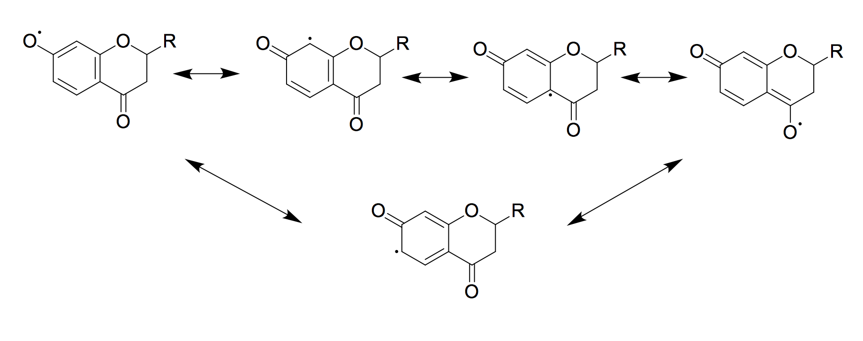
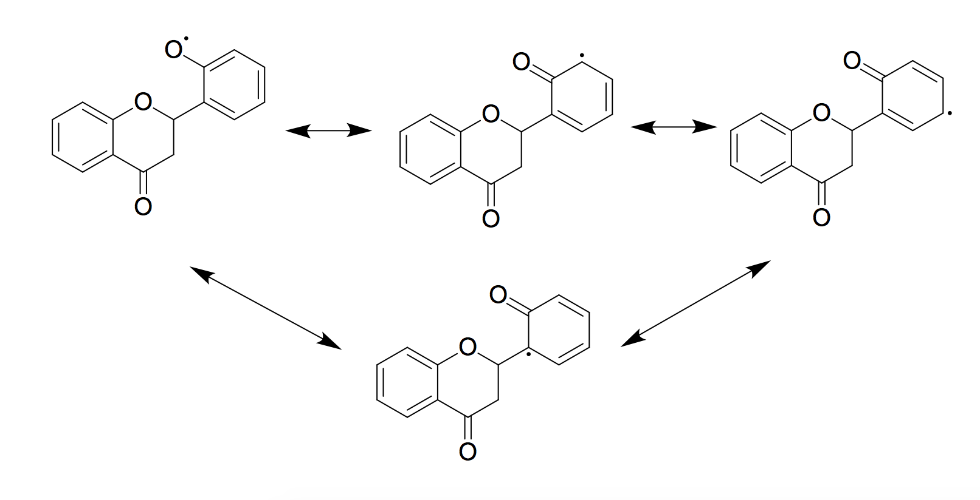
Scheme 1. Possible resonance structures for 7-HF (A) and 2’-HF (B), where R = phenyl functional group.
A
B

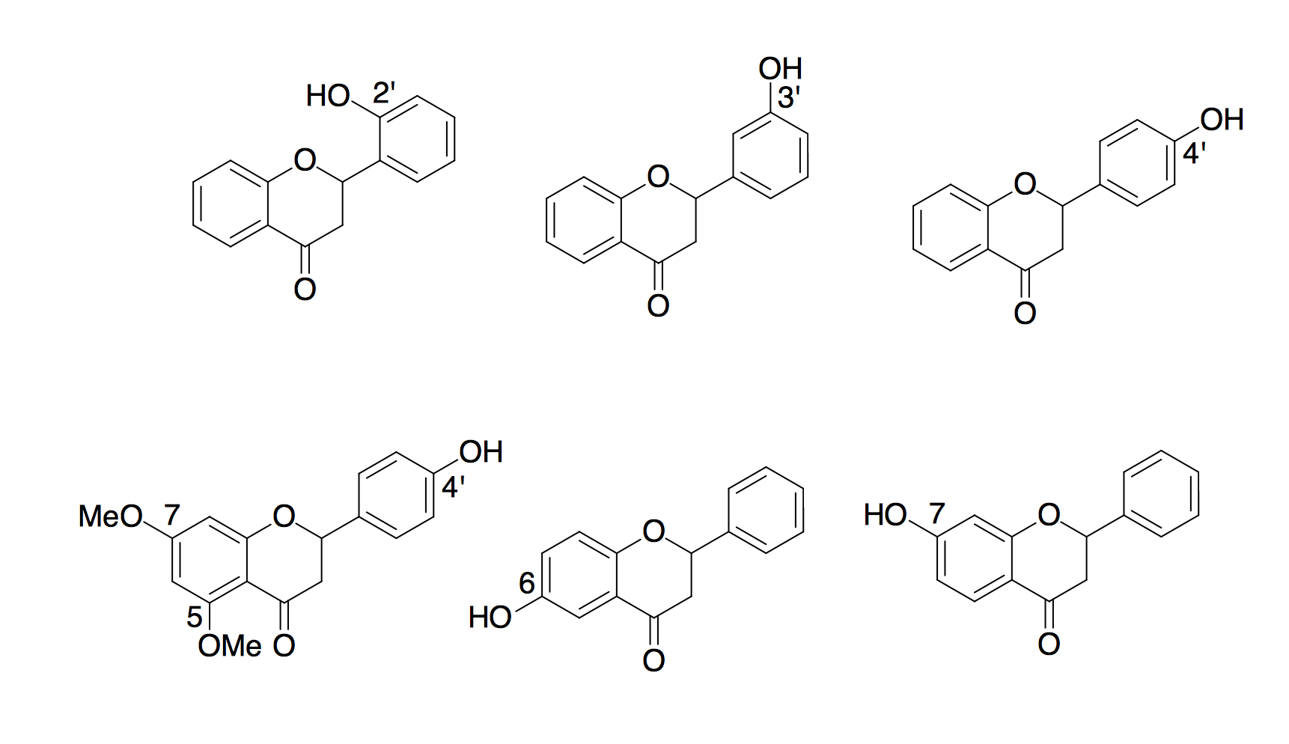
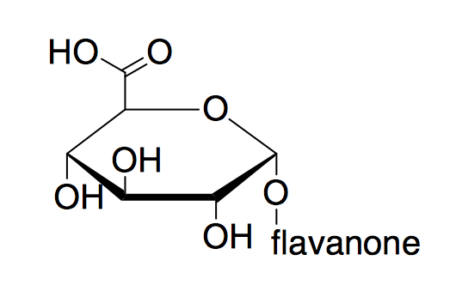
Figure 1. Structure of six hydroxyflavanones (HF) investigated in this study and the general structure of a flavanone glucuronide.

A ring
picryl ring
B ring
2’-HF
3’-HF
4’-HF
5,7-dimethoxy-4’-HF
6-HF
7-HF
Flavanone glucuronide

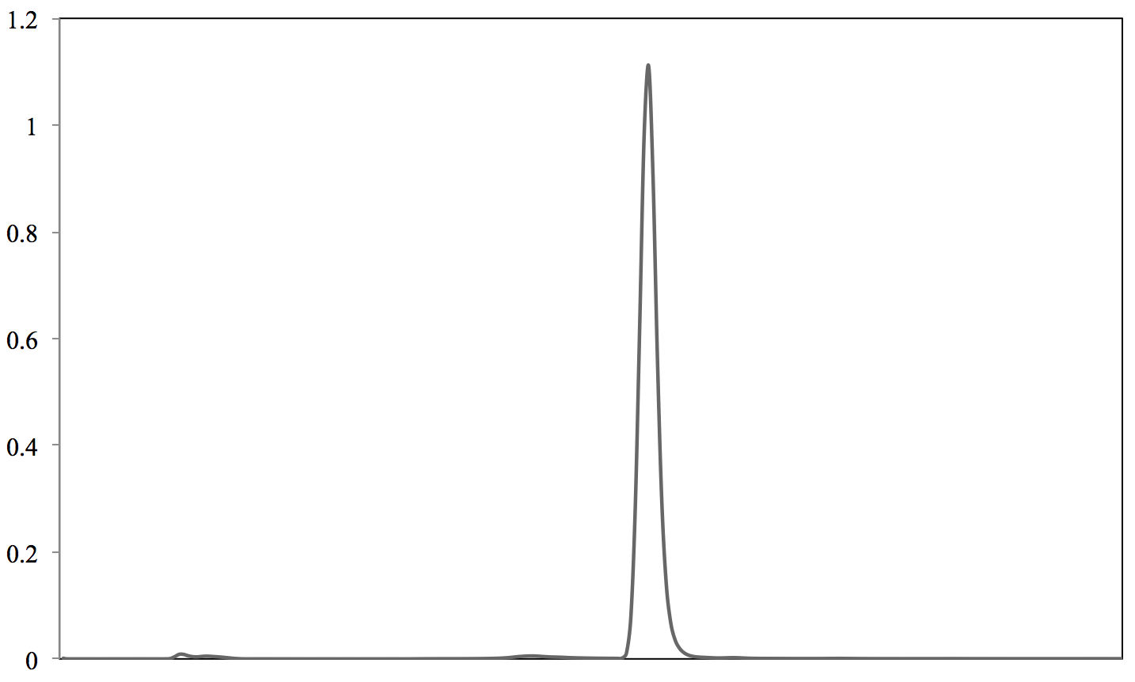
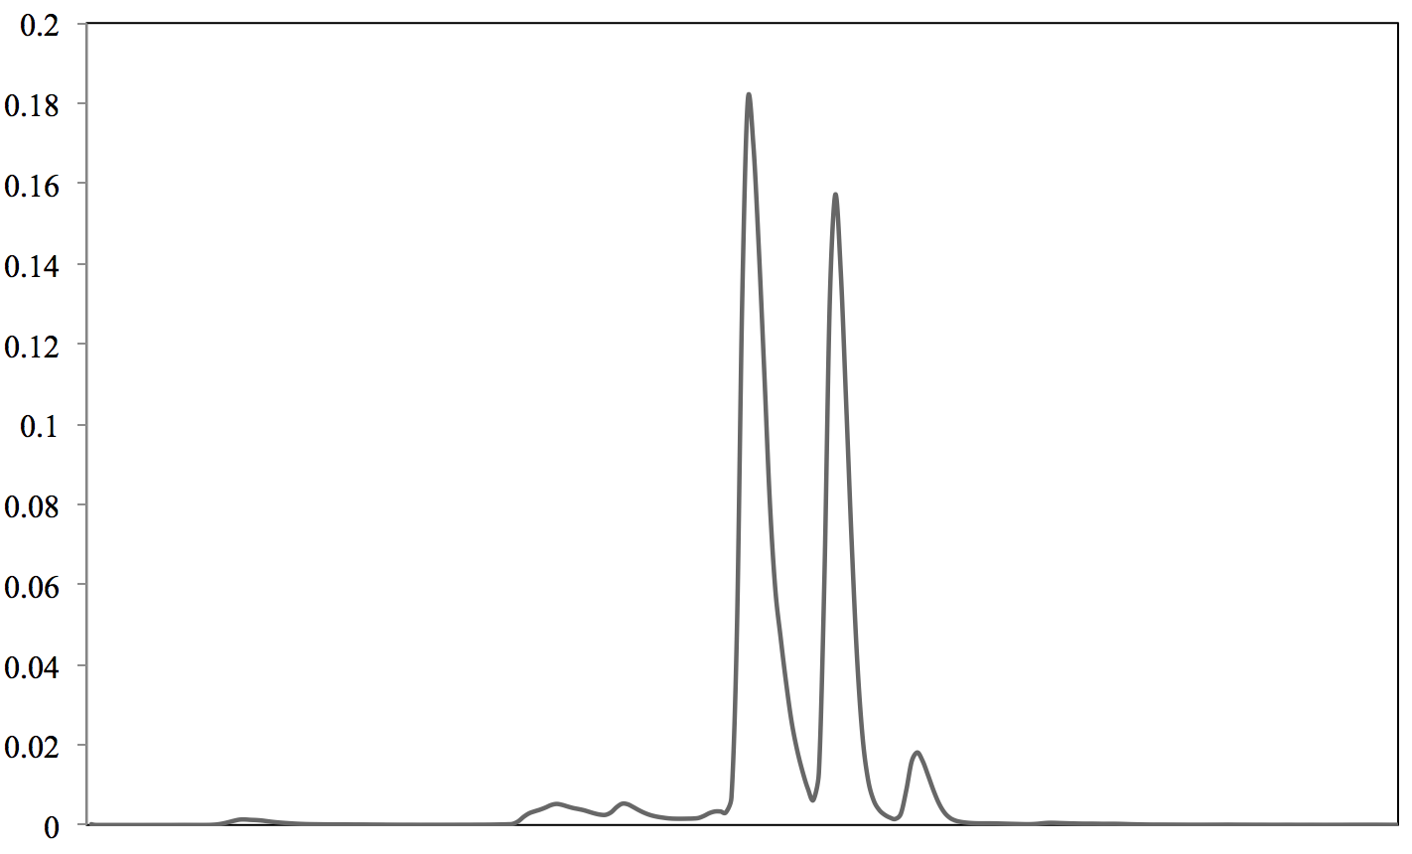
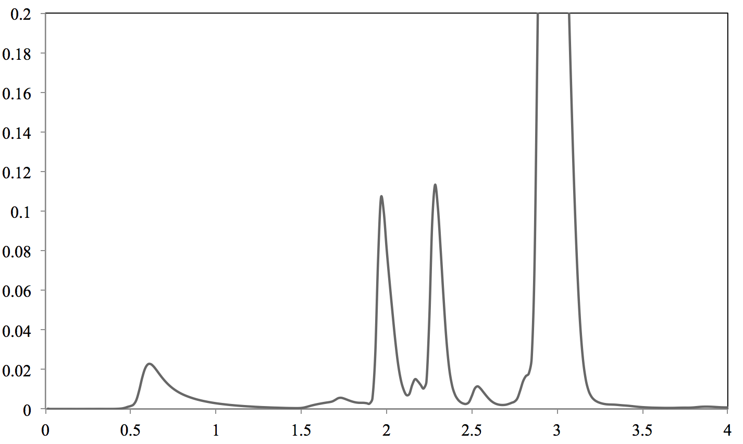
Figure 2. Representative chromatograms of flavanones and corresponding glucuronide metabolites (A) 7-hydroxyflavanone (B) 7-hydroxyflavanone and 7-O-glucuronide (C) 7-hydroxyflavanone and 7-O-glucuronide after incubation with DPPH.

Absorbance
Time (min)
A
B
C
Flavanone
Flavanone glucuronide
Flavanone
Flavanone
Flavanone glucuronide
DPPH

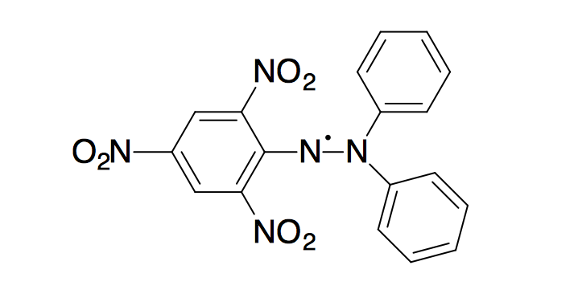
Figure 3. Structure of the DPPH free radical.

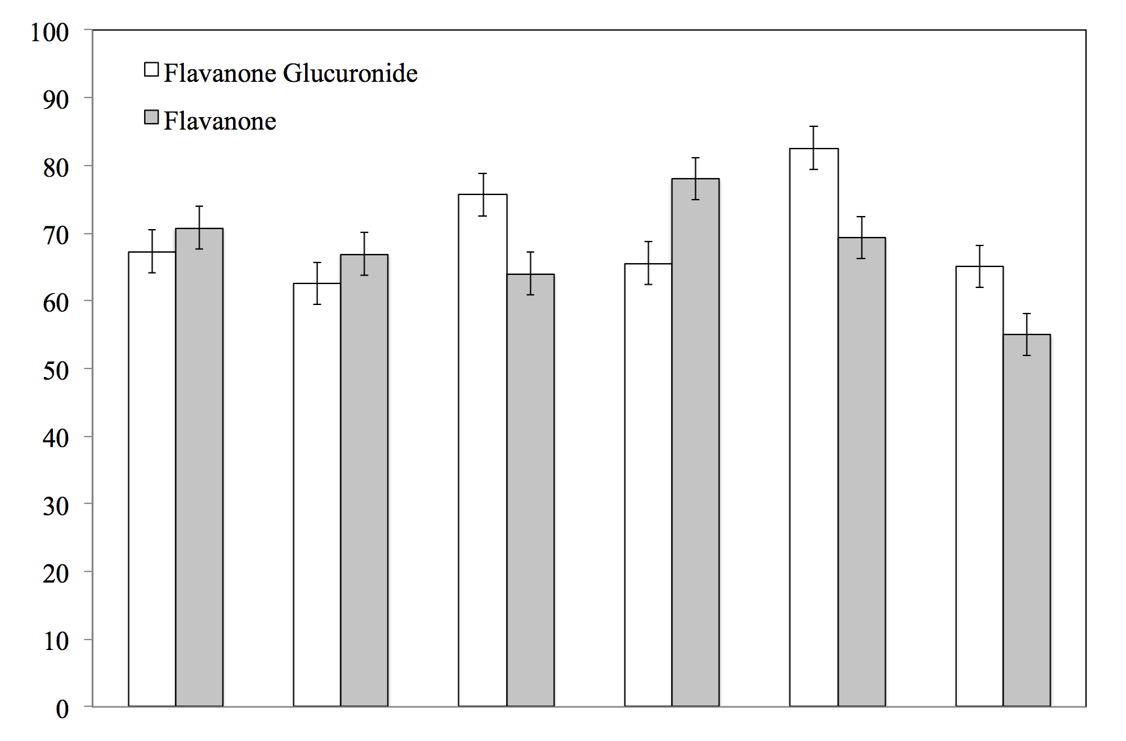
Figure 4. Percent of flavanone and glucuronide metabolite remaining after reaction with DPPH. Error bars represent standard error calculated from the analysis of replicate samples.

2’
3’
4’
5,7-
dimethoxy-
4’
6
7
Percent Remaining

